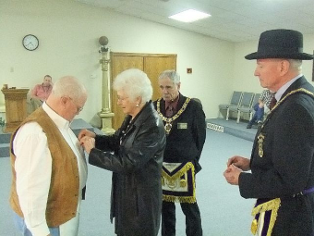
On April 18th 2013, Brother Gene Bass of Henderson Lodge #477 received his 50 Year Pin & Certificate from Most Worshipful David L. Ramsey. His wife Joann is shown presenting him with the pin.

